**ERP User manual**

**Self Service**

Prepared for:

**AERC Delivery Secretariat**

Prepared by:



**ATTAIN ENTERPRISE SOLUTIONS LTD**

**P.O. Box 18286 – 00100,**

**Nairobi.**

**Tel: 020 2715680**

**Email:** [**admin@attain-es.com**](mailto:admin@attain-es.com)

**Website:** [**www.attain-es.com**](http://www.attain-es.com)

Table of contents

Self Service 3

1. Purchase Requisitions 4

2. Store Requisitions 6

3. Leave application 7

4. Employee Leave Records 10

4. Leave Plan List 11

5. Employee Training Needs List 14

6. Training Evaluations 16

7. Travel Request 18

8. Employee Training Request 20

9. Appraisal Objectives Setup List 22

10. Appraisals List 27

11. User Support/ Incidences list 33

12.Resources/ Key Requests 35

13. My Career History Log 37

14. Maintenance Requests List 38

15. Grievance List 39

16. Approval Delegations 41

17. Active Approval Delegations 43

18. Approval Request Entries 44

19. Approval Entries 45

20. Imprest/Advance Request 46

21. Imprest/Advance Surrender 49

22. Claims Refund Listing 51

23. Education Benefits 53

24. Health Club Claims 55

25. Employee Medical Claims 57

21. Sick Offs List 59

# Self Service

The general user window is used by all organizational users to access NAV 2015 application areas meant for all users. To access the General Users window:

• Click **Departments** in the Navigation Pane and Select **Self Service**

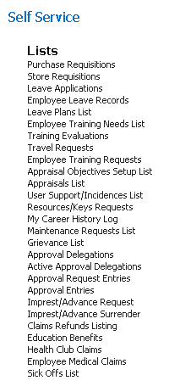

FIGURE 1.1 *General Services List*

# Purchase Requisitions

To apply for a Purchase Requisition, follow these steps:

1. Click the **Departments** select **self-service**

2. On the Self Service list, select **Purchase requisitions** 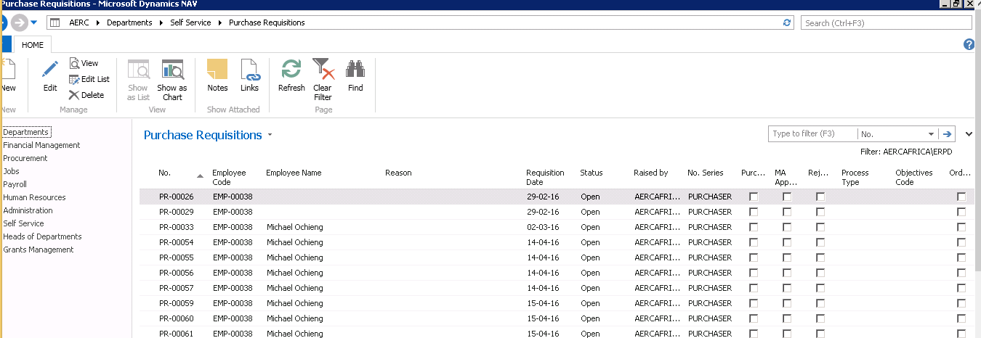

FIGURE 1.2 *Purchase Requisition List*

3. Click **New** and fill out the resulting form.

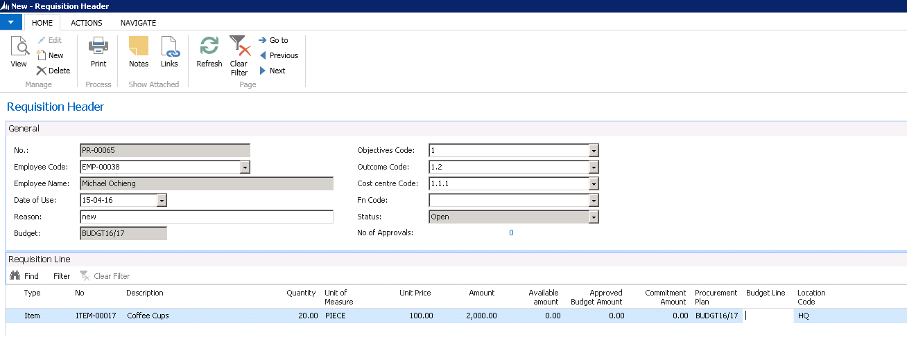

FIGURE 1.3 *Purchase Requisition*

4. The field No., Employee code and Employee name is auto populated based on the employee that is making the purchase request/ indent. The Budget field picks what has already been set up by procurement as the current Budget.

5. In the Requisition line, one specifies the items for which they are making a procurement request

6. In the Procurement Plan Item field select the procurement item from the list.

**Note:** Incase the item is not in procurement plan leave the field blank.

3. In the Type field, select if it is an item or an expense (G/L Account)

4. In the No. field, select the item

5. Update the Description field, if necessary.

6. In the Quantity Type field, enter the quantity, also unit of measure and unit price if known

7. Once satisfied with information provided, click on the Navigate tab.

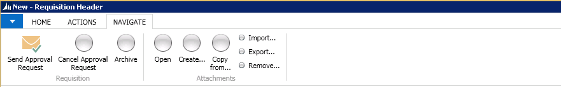

FIGURE 1.5 *Navigate Tab*

Select **Send Approval Request**. The request is sent the respective approver. The status of the request changes to Pending Approval. Should the sender wish to recall their request before it is approved, they can click on **Cancel Approval Request**. Otherwise it cannot be recalled.

# Store Requisitions

To apply for a Store Requisition, follow these steps:

1. Click the **Departments** tab and Select **Self Service**

2. On the Self Service list, select **Store Requisition**

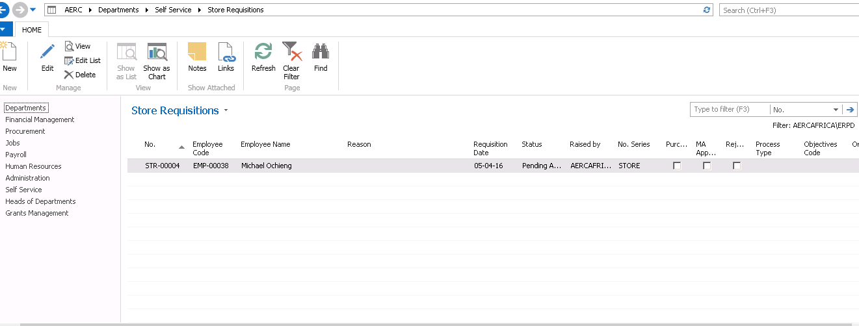

FIGURE 1.5 *Store Requisition List*

3. Click **New** and then fill out the resulting form

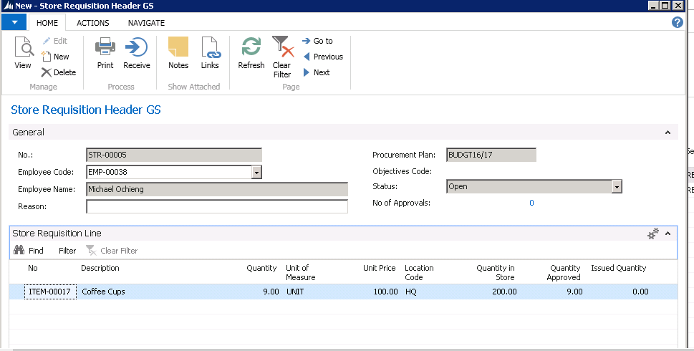

FIGURE 1.6 *Store Requisition*

4. The field No., Employee code and Employee name is auto populated based on the employee that is making the store requisition

5. In the Store Requisition line, one specifies the items for which they are making a Store request

6. In the No. field, select the item (this automatically populates the Quantity in store field)

7. In the Quantity field, enter the number of items required

8. Once satisfied with information provided, click on the Navigate tab.



Select Send Approval Request. The request is sent the respective approver. The status of the request changes to Pending Approval. Should the sender wish to recall their request before it is approved, they can click on **Cancel Approval Request**. Otherwise it cannot be recalled.

# Leave application

This is where an employee will apply for leave and all their leave applications are listed.

1. Click on **Departments** Select **Self Service**

2. On the Self Service list, select **Leave Application**

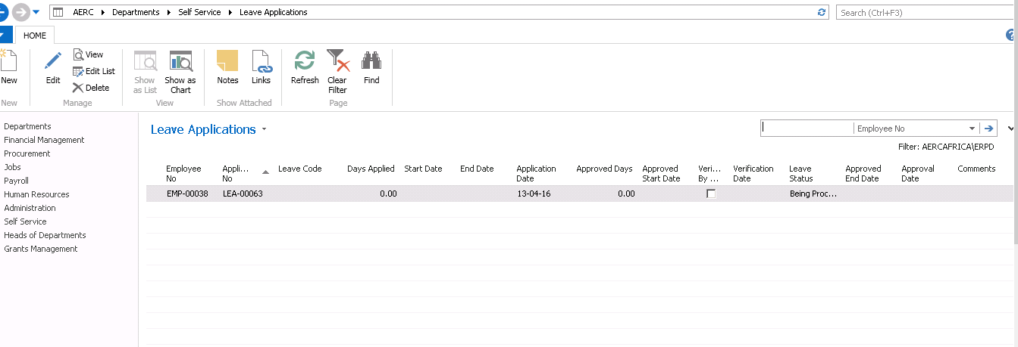

FIGURE 1.7 *Leave Application List*

3. Click **New**

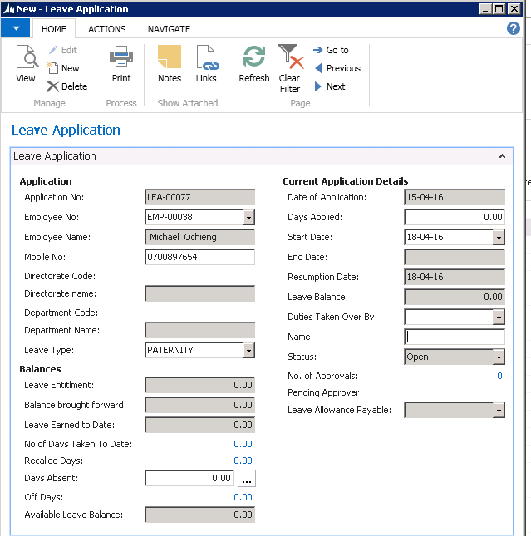

FIGURE 1.8 *Leave Applications*

4. The field Application No., Employee No. and Employee Name, Mobile No., Department is auto populated based on the employee that is making the application

5. **The Leave Type** **must** be selected. This will update the **Balances** section when the leave type is Annual. The leave entitlement, Balance brought forward from previous year if any, Leave earned to Date, No of days for which leave has been taken, the number of days that employee was recalled, absent and off Days are all displayed.

6. The Current Application Details:

* In the Days applied field, enter the no of days for to go for leave
* In the Start Date field, select the beginning date.
* The End Date and the Resumption Date fields are auto filled based on the number of days selected and the start date.
* In the Duties taken over by, select the person to handle duties when away

8. Once satisfied with information provided, click on the Navigate tab.



Select Send Approval Request. The request is sent the respective approver. The status of the request changes to Pending Approval. Should the sender wish to recall their request before it is approved, they can click on **Cancel Approval Request**. Otherwise it cannot be recalled.

# 4. Employee Leave Records

This contains all an employee’s records of leave and leave recalls.

1. Click on **Departments** Select **self-service** under employee leave records

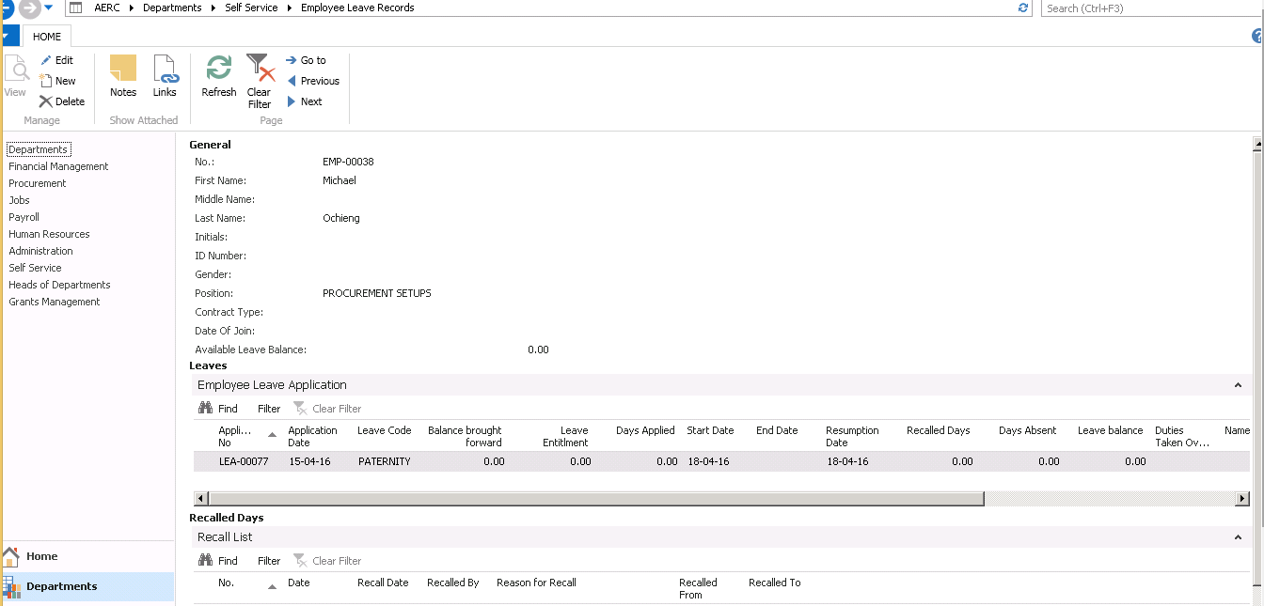

FIGURE 1.9 *Employee Leave Records*

Leave records are generated from the leave application forms. It displays all leave records as applied for by the employee i.e. the leave application history. Note the column showing the leave status. The days recalled are also displayed.

# Leave Plan List

This is used by the employees to create their annual leave plans. All employee leave plans form the departmental leave plan and are incorporated into the corporate leave plan.

1. Click **Departments** Select **Self Service** >**Leave plan list**
2. The list contains a list of all leave plans created

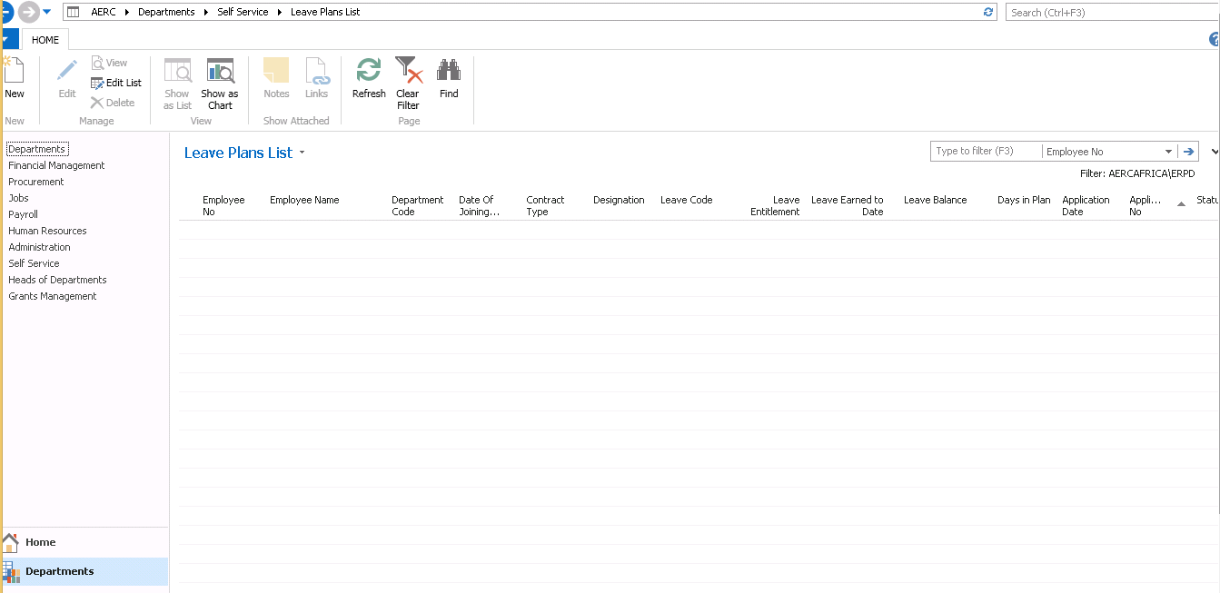

FIGURE 1.10 *Employee Leave Plan List*

1. Click on **New** to create a new leave plan.

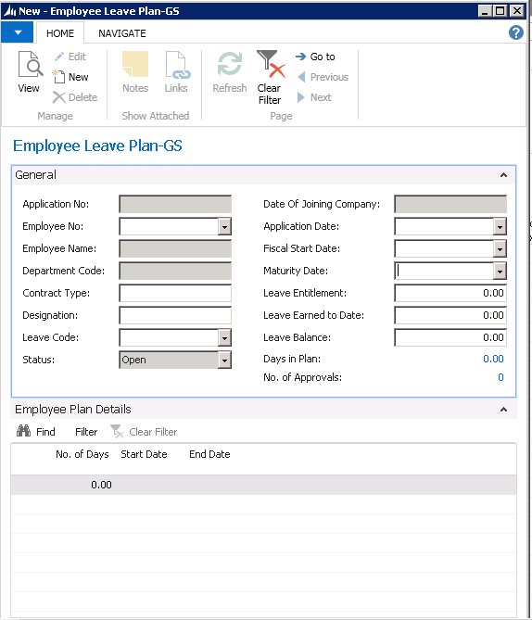

FIGURE 1.11 *Employee Leave Plan*

1. Employees can enter their annual leave plans on this page. The employee number, name and application number are auto populated. Select the Leave Code. The rest of the details on the General tab of the form
2. Enter the No. of days
3. Enter the expected Start date
4. The End date will be system calculated
5. Once all the details are filled, click on the Navigation tab and click on Send Leave Plan

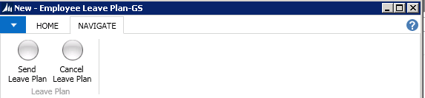

This ensures the plan is sent to the HOD for approval and to HR.

# Employee Training Needs List

This is used by employees to state the training needs they require.

1. Click **Departments**  **Self Service >Employee Training Needs List**
2. The list contains a list of employees training needs.

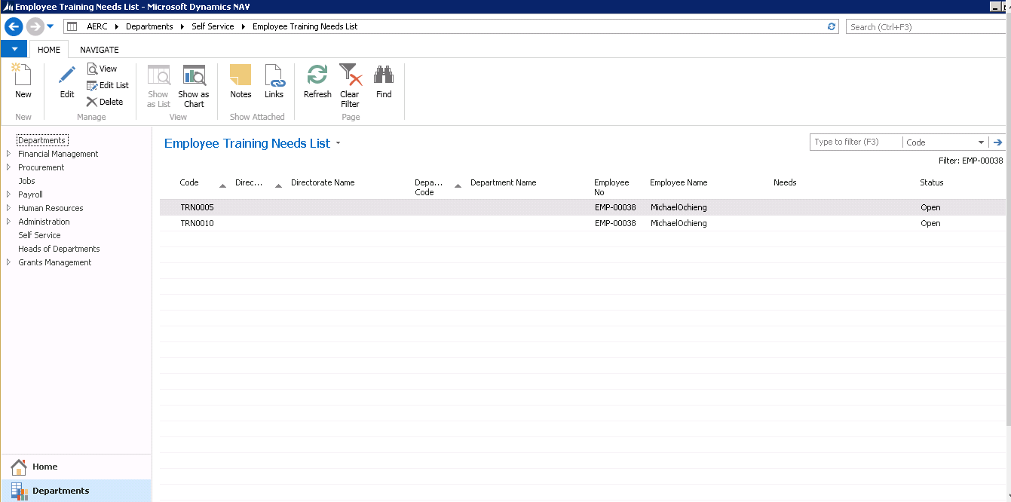

1. To add a newtraining need click **New** and fill in all the required fields. 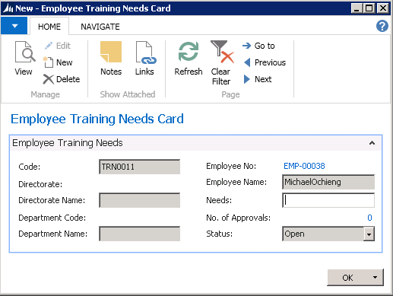
2. Once you are done with the request, click on the Navigation tab and click on **Send Approval Request.** It then sends the request to the relevant approver. 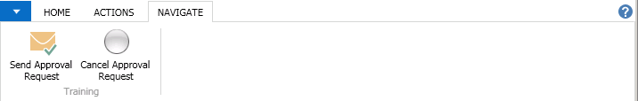

# Training Evaluations

This is used by employees for evaluating the training details 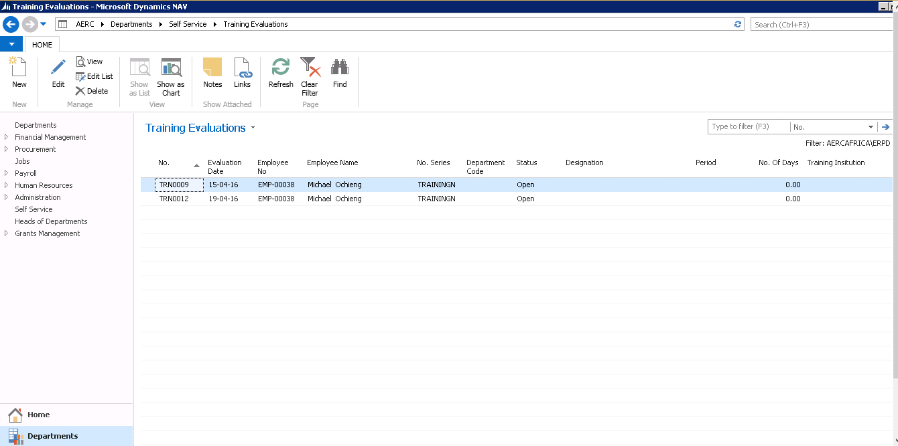.

FIGURE 1.13 *Training Evaluations*

To make a new training evaluation click **New** and fill in all the required fields. 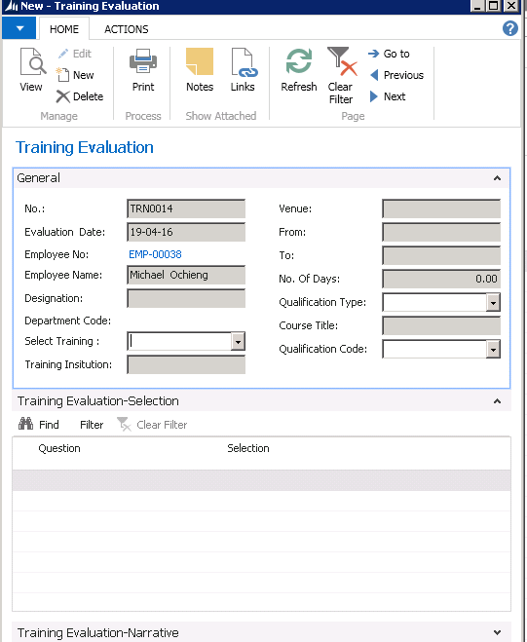

FIGURE 1.14 *Training Evaluation form*

# Travel Request

To apply for Transport, follow these steps:

1. Click on **Departments**>**Self-Service>Travel Requests**

2. Select **Travel requests** The list of all travel requests made by the user are displayed.

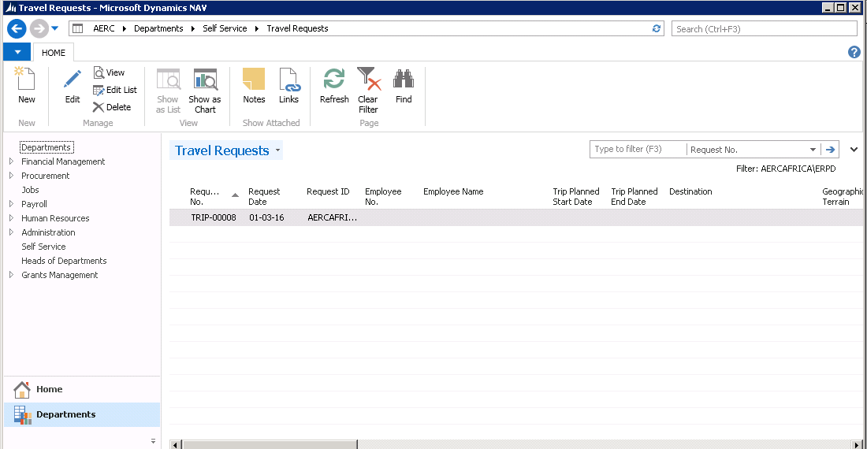

FIGURE 1.15 *Transport Request List*

3. Click **New** and fill out the resulting form.

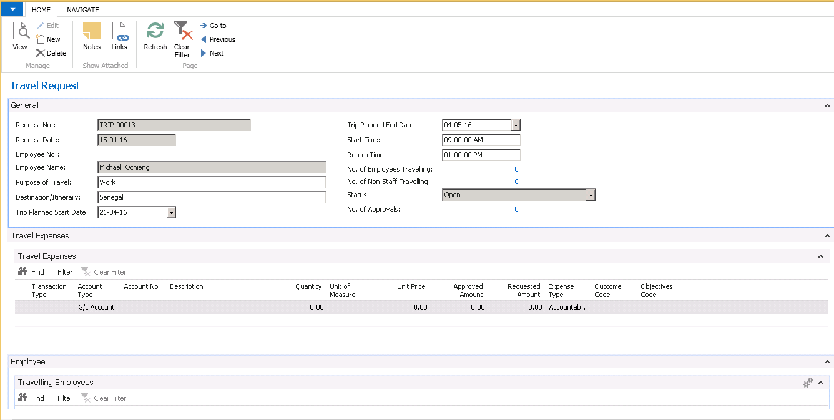

FIGURE 1.16 *Travel Request*

4. The field Request No., Employee No. and Employee Name, are auto populated based on the employee that is making the application.

5. On the General fast tab fill in the **Purpose of Travel** field and the **Destination/Itinerary** field as appropriate.

6. Enter the **Trip Planned Start date** and **Start Time** and **Trip Planned End date** and **Return time** in their respective fields

7. On the Employee fast tab, select the employees who are going for the trip from the employee drop down list

8. In case there are non-employees who will accompany employees for the trip enter their details in the Non-employee fast tab

9. Click **Navigate** on the menu bar and select **Send Approval Request**. The request is sent to appropriate approver.

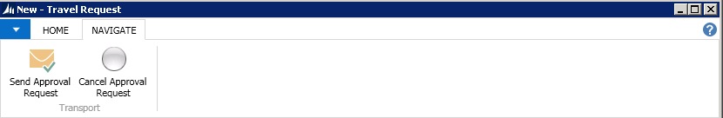

# Employee Training Request

1. Click **Departments**  **Self Service >Employee Training Request**
2. The list contains a list of employees training requests.

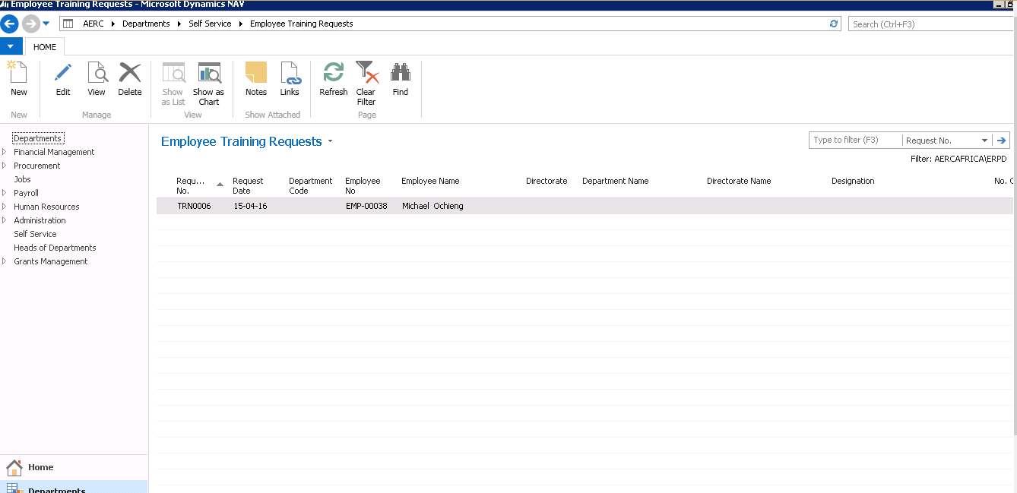

FIGURE 1.12 *Employee Training Request List*

1. To add a newtraining request click **New** and fill in all the required fields.

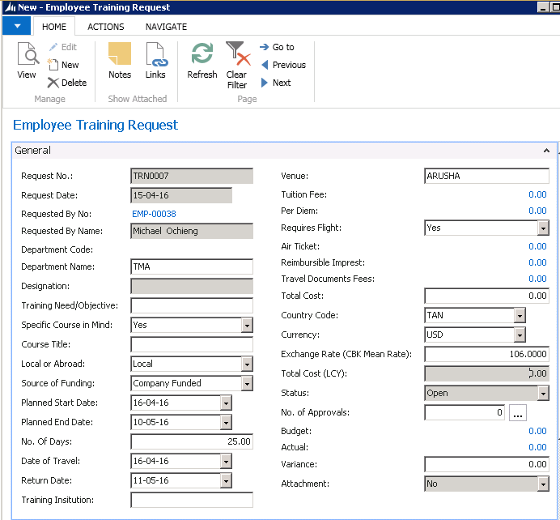

FIGURE 1.13 *Employee Training Request*

1. Once you are done with the request, click on the Navigation tab and click on **Send Approval Request.** It then sends the request to the relevant approver.



FIGURE 1.13 *Training Evaluation form*

3. The field No., Employee No. and Employee Name, are auto populated based on the employee that is making the application

4. In the Select Training field, select the training for which evaluation is being done

5. On the Training Evaluation lines, a series of questions are displayed. To respond to the questions the user either ticks the selection column or Selects the appropriate response from the Answer column (for example Strongly Agree)

# Appraisal Objectives Setup List

This contains a list of all the Employee Appraisal Objectives. Employees log into the system and create their Individual appraisal objectives which will be used during performance appraisal.

1. Click on Appraisal Objectives Setup List.

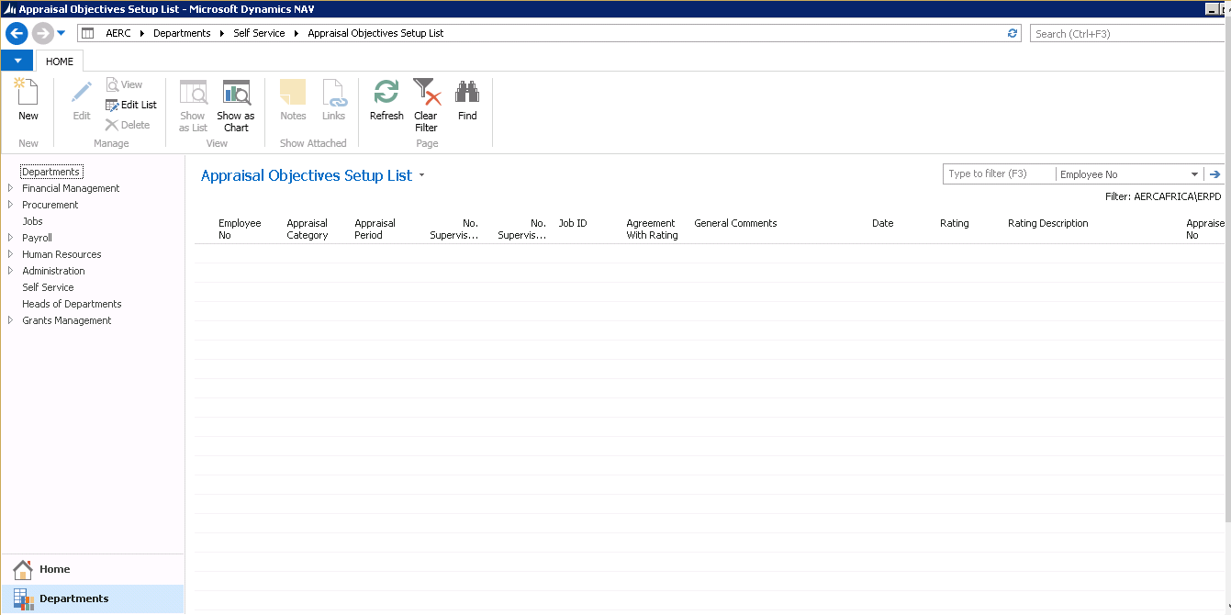

FIGURE 1.17 *Appraisal Objectives List*

1. To add a new appraisal click on the **New** Button. To edit an existing appraisal click on the **Edit** Button after selecting the appraisal to edit.

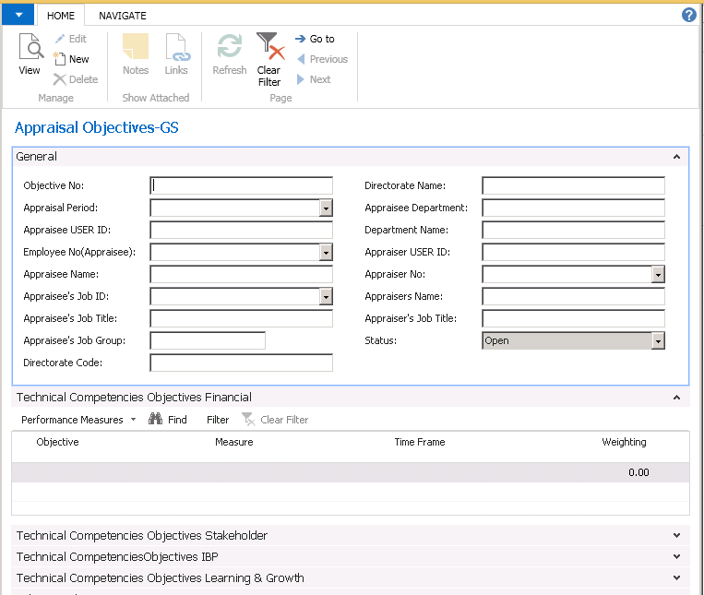

FIGURE 1.18 *Appraisal Objective*

**General Tab**

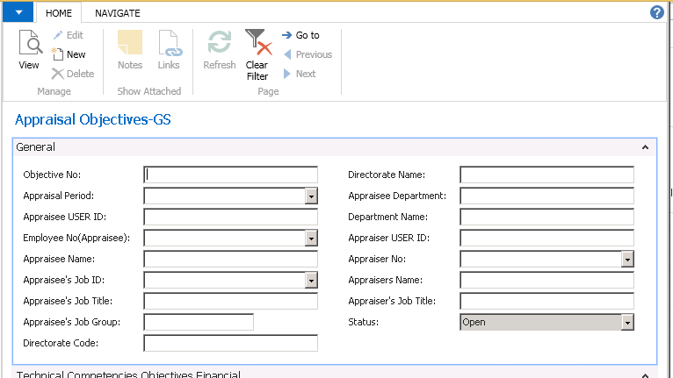

The employee’s fills in all the required fields, this mostly contains the employee’s data this is under the **General Tab**

**The Performance indicators are under the two tabs**

**Technical Competencies**

This is where the employee states the objectives that will be used to measure the performance during the appraisal under technical competencies

It has the following areas,

* Objectives technical competencies financial

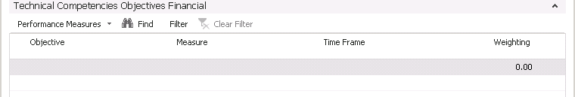

* Objectives technical competencies internal business process

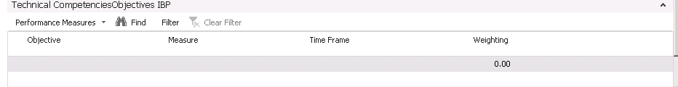

* Objectives technical competencies stakeholder

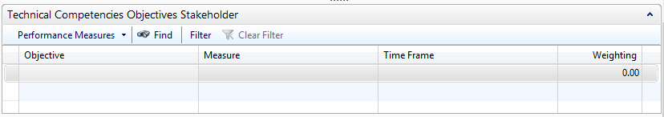

* Objectives technical competencies Learning

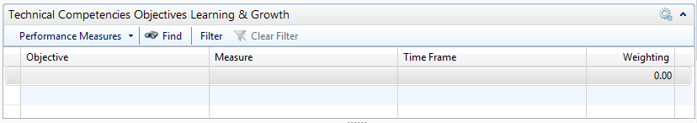

For each an employee must state specify the following,

**Objective**-This is the specific objective that has been set by the employee e.g.

**Measure**-This is the how the objective will be measured to see if it has been achieved

**Time Frame**-The time period it will take to achieve the objective

**Weighting**-The percentage out of 100 the objective will take, taking into consideration the total performance score

**Behavioral Competencies**

This is where the employee states the Time frame and measure of their behavioral competencies.

The objectives and Weighting (totaling to 100) are already set in the system, therefore the user only states the measure and timeframe

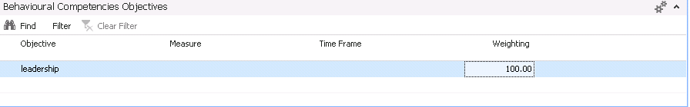

1. Thereafter the employee appraisal objectives are sent to their particular supervisor for Approval and thereafter to the Human Resource Department after approval by the supervisor. This is by clicking on Navigate > **Send Approval Request.** 

# Appraisals List

1. Click on Self Service> **Appraisals**

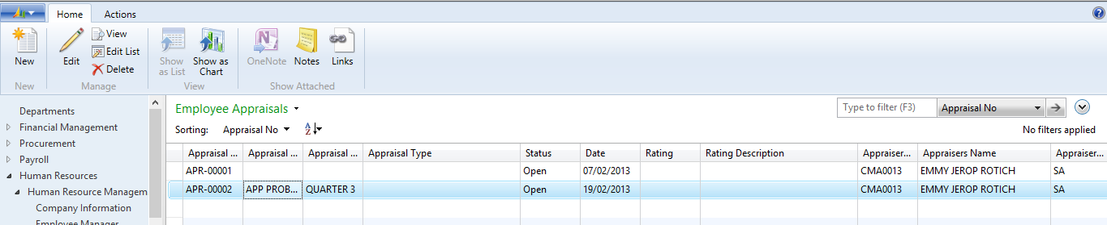

FIGURE 1.19 *Employee Appraisal List*

1. To add a new appraisal click on the **New** button. To edit an existing appraisal click on the **Edit** button after selecting the appraisal to edit.

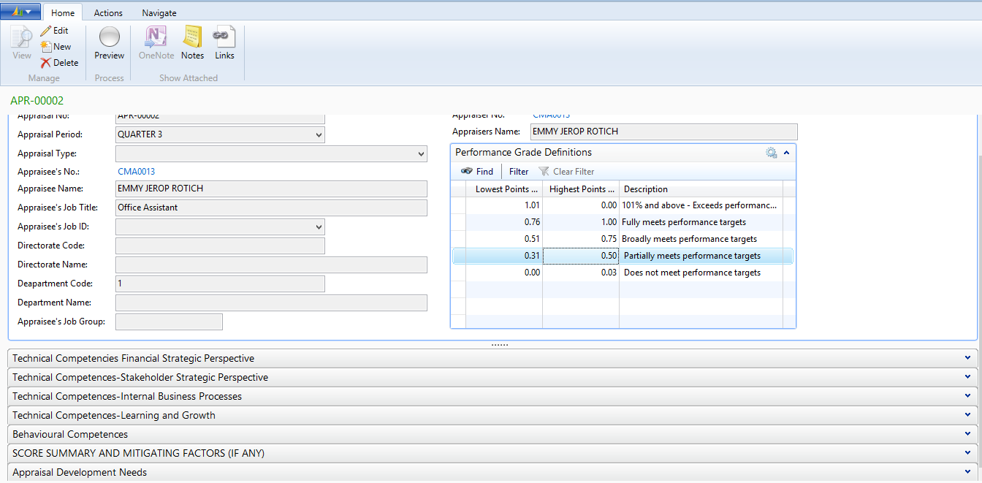

FIGURE 1.20 *Employee Appraisal*

**General tab**

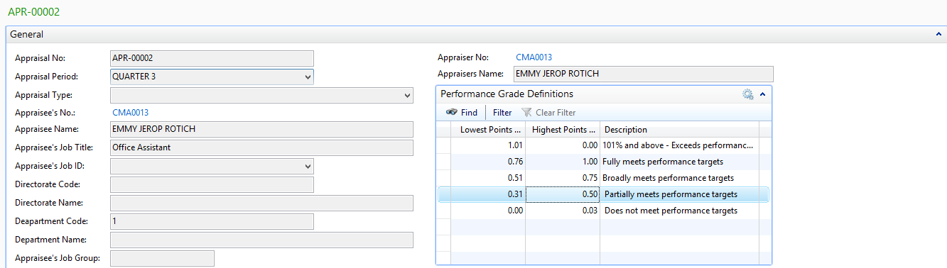

This contains the general details of the employees, the employee fills in all the fields.

The **Performance Grade Definitions** tab contains a reference point when doing the appraisal.

**Technical Competencies Financial Strategic Perspective**

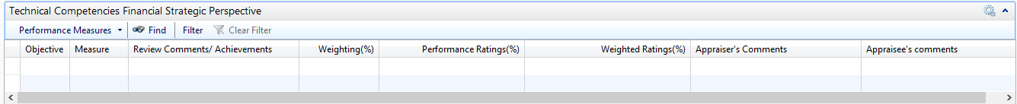

The following fields data will be obtained from the Technical Competencies set in the Employee Appraisal Objectives, they include the:

Objective

* Measure
* Weighting

While the other fields:

* **Review Comments/Achievements**
* **Performance Rating**-User inputs taking into account the objectives that need to be fulfilled
* **Weighted Ratings**-Total Weighted which is calculated by dividing the weighting with the performance rating
* **Appraiser’s comments**
* **Appraisee’s comments**

**Technical Competencies Stakeholder Strategic Perspective**



The following fields data will be obtained from the Technical Competencies set in the Employee Appraisal Objectives, they include the:

* Objective
* Measure
* Weighting

While the other fields:

* **Review Comments/Achievements**
* **Performance Rating**-User inputs taking into account the objectives that need to be fulfilled
* **Weighted Ratings**-Total Weighted which is calculated by dividing the weighting with the performance rating
* **Appraiser’s comments**
* **Appraisee’s comments**

**Technical Competencies Internal business Processes**

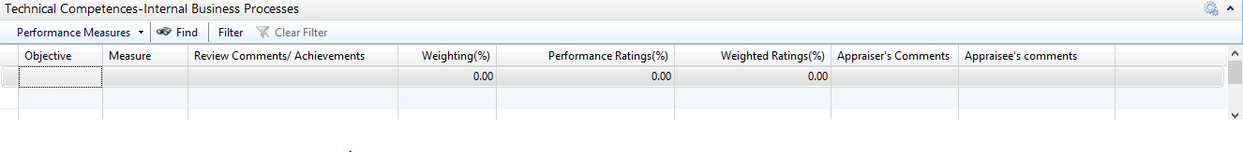

The following fields data will be obtained from the Technical Competencies set in the Employee Appraisal Objectives, they include the:

* Objective
* Measure
* Weighting

While the other fields:

* **Review Comments/Achievements**
* **Performance Rating**-User inputs taking into account the objectives that need to be fulfilled
* **Weighted Ratings**-Total Weighted which is calculated by dividing the weighting with the performance rating
* **Appraiser’s comments**
* **Appraisee’s comments**

**Technical Competencies Learning and Growth**



The following fields data will be obtained from the Technical Competencies set in the Employee Appraisal Objectives, they include the:

* Objective
* Measure
* Weighting

While the other fields:

* **Review Comments/Achievements**
* **Performance Rating**-User inputs taking into account the objectives that need to be fulfilled
* **Weighted Ratings**-Total Weighted which is calculated by dividing the weighting with the performance rating
* **Appraiser’s comments**
* **Appraisee’s comments**

**Behavioral Competencies**

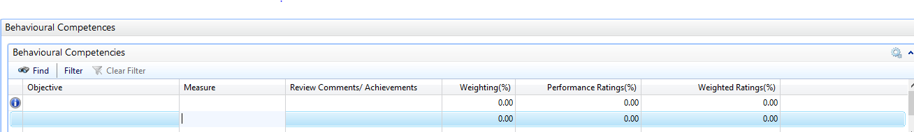

The following fields data will be obtained from the Behavioral Competencies set in the Employee Appraisal Objectives, they include the:

* Objective
* Measure
* Weighting

While the other fields:

* **Review Comments/Achievements**
* **Performance Rating**-User inputs taking into account the objectives that need to be fulfilled
* **Weighted Ratings**-Total Weighted which is calculated by dividing the weighting with the performance rating

**Score Summary and Mitigation Factors (IF ANY)**

This tab contains the score summary and mitigation if any.

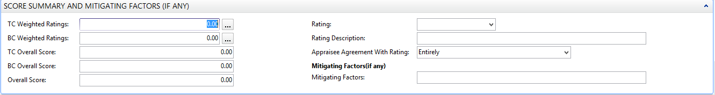

It has the following fields:

* TC Weighted Ratings-This is the Total Technical Competencies Ratings from the all TC weighted Rating
* BC Weighted Ratings- This is the Total Behavioral Competencies Ratings from the all BC weighted Rating
* TC Overall Score-This obtained by multiplying TC weighted Ratings by a given percentage (usually 80%)
* BC Overall Score- This obtained by multiplying TC weighted Ratings by a given percentage (usually 20%)
* Overall Score-This is the total score which is obtained by adding the TC Overall Score
* Rating-This is the rating obtained as per the Performance Grade Definitions
* Rating Description- This is a description of the rating from the General-Performance Grade Definitions
* Appraisal Agreement with Rating-This is where the employee selects from the drop down whether the rating selected is in agreement with the appraisal.
* Mitigation Factors –This is the actions if any to be taken as per the ratings

**Appraisal Development Needs**

From the Appraisal performance this section allows an employee or the appraise to add development needs that will allow the employee to improve their performance rating 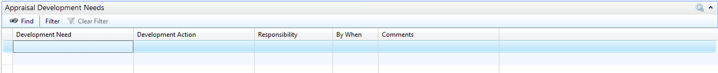

The fields to be filled are:

* Development Need-This the need e.g. Need for training in Finance
* Development Action-This is the action that is to be taken e.g. Attend Finance Training
* Responsibility-the person who is in charge of the action to be taken.
* By When- this is the date by when the action should be taken
* Comments

1. Afterwards the appraisal is sent for approval. This is by clicking on Navigate > **Send Approval Request.**

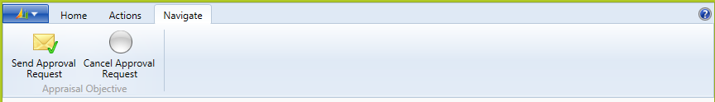

# 11. User Support/ Incidences list

To report user incidences, follow these steps:

1. Click Departments>Self Service.

2. Select **User Support/ Incidences List**.

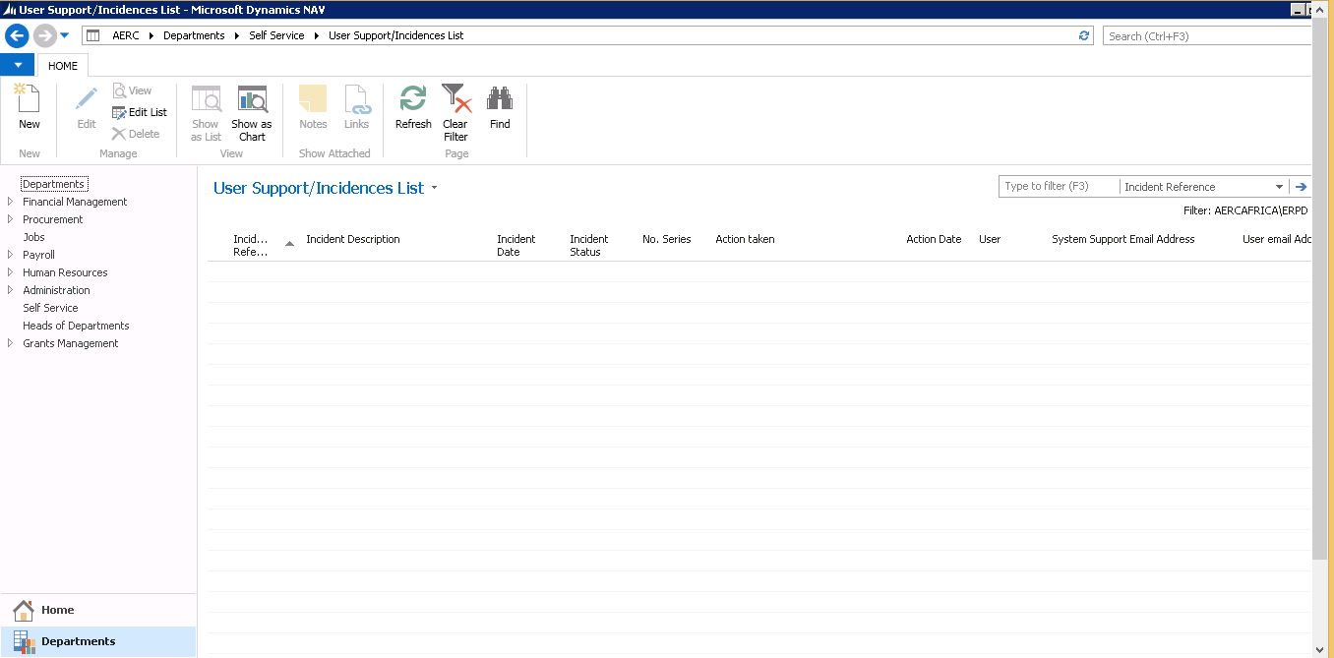

FIGURE 1.21 *User Incidences List*

1. Click **New** and fill out the incidences

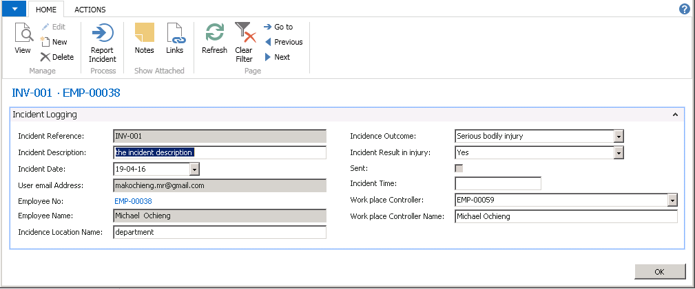

FIGURE 1.22 *User Incidences Card*

4. The field Incidence Reference No., is auto populated

5. In the Incident Date field select the date using the calendar.

6. Enter the incidence Location name and select the incidence outcome

7. In the Incident time field enter the time the incident occurred

8. Click **Report Incident** button on the Action pane. This sends the incident to Administration.

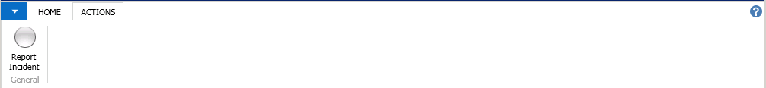

# Resources/ Key Requests

This is used to request for resources from the Administration/ Human Resource Department.

1. Click on Departments>Self Service > **Resources/Keys Requests**

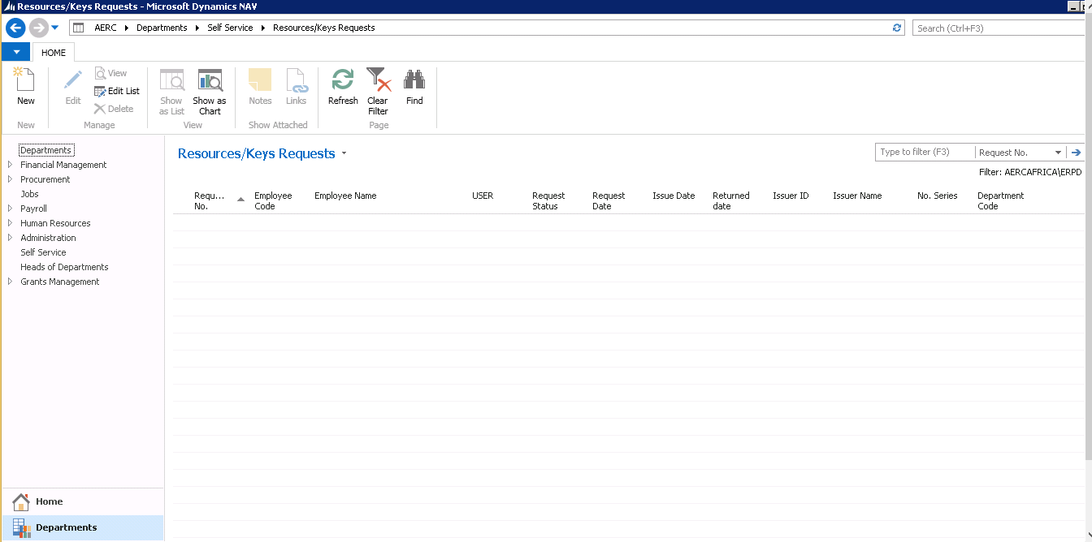

FIGURE 1.34 *Resources/Keys Requests*

1. Click **New** and fill out the request form by keying in the relevant details.

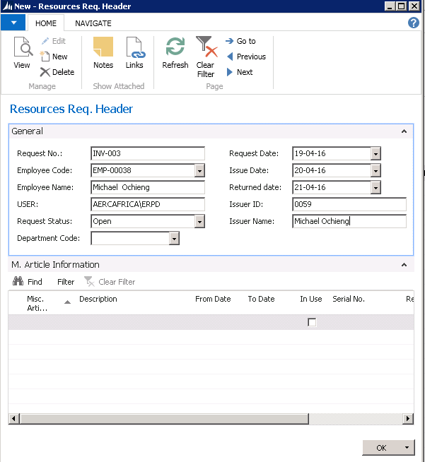

FIGURE 1.35 *Resources/key Requests card reader*

1. The request No. is auto filled as the rest of the details need to be populated. The resource being requested for is captured on the M. Article Information lines.
2. The completed request form is sent for approval by clicking on Navigate> Send Request.

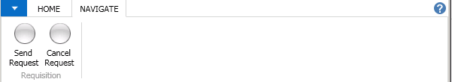

# 13. My Career History Log

Click on employee self-service > **My Career History Log**

This shows a history of an employee’s career in the given organization.

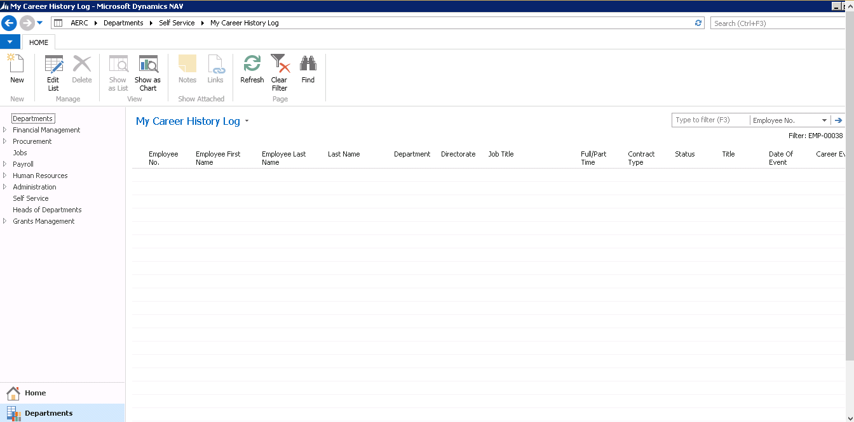

FIGURE 1.29 *My Career History Log*

# 14. Maintenance Requests List

This is used to request for maintenance on miscellaneous items such as chairs and desks to be acted upon by the Administration.

1. Select **Departments**>**Self Service**> **Maintenance Request Lists**.

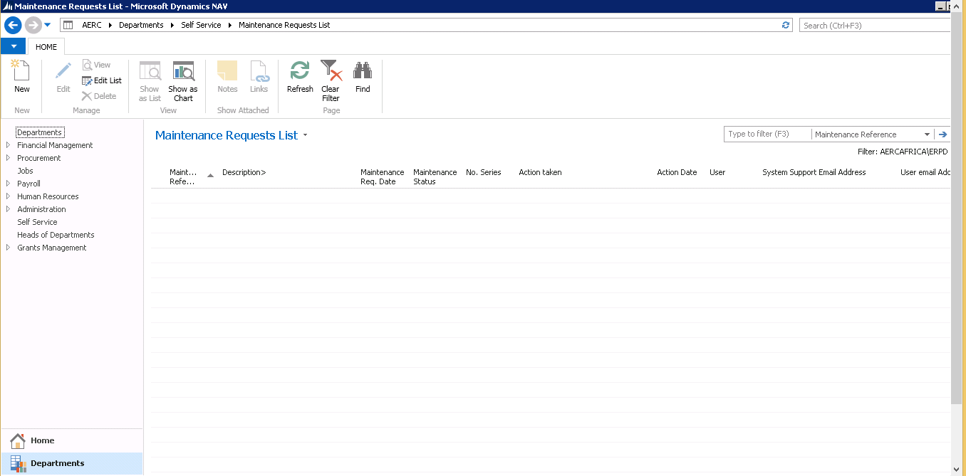

FIGURE 1.36 *Maintenance Request List*

1. Click **New** and fill out the details on the maintenance request form. 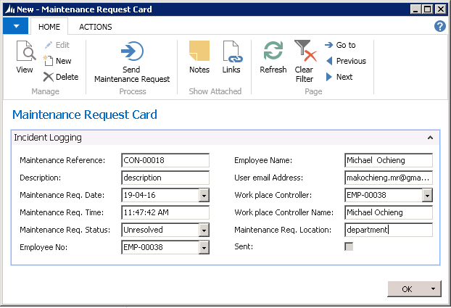

FIGURE 1.37 *Maintenance Request Card*

1. Send the request to the administration by clicking Send Maintenance Request.

# 15. Grievance List

1. On the Navigation pane click **Departments>Self Service>Grievance List**

This shows a list of grievances of people with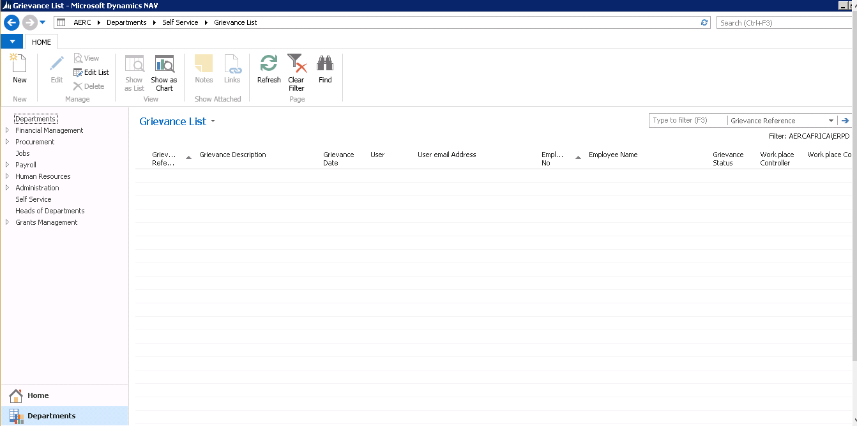in the organization.

3. Click **New** and populate the resulting form to make a new grievance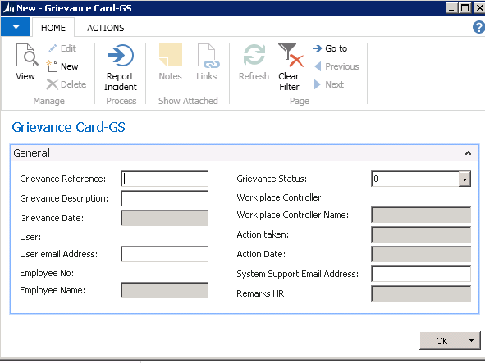

# Approval Delegations

This functionality is allows the user to delegate their functions and approval rights to another user when they intend to be out of office.

1. Select **Departments**>**Self Service**> **Approval Delegations**

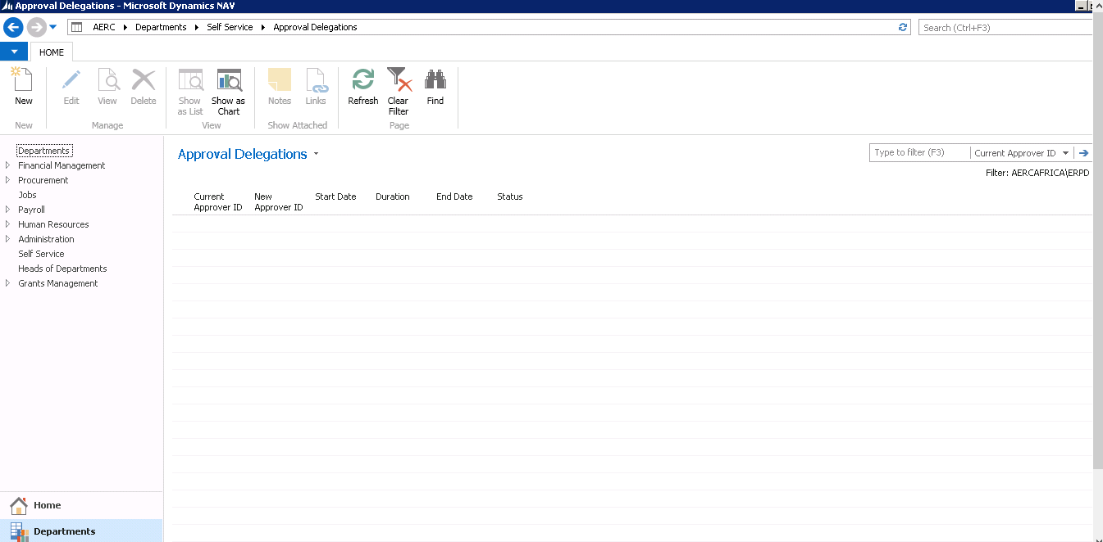

FIGURE 1.38 *Approval Delegations List*

1. Click **New** and select the user who will take over your duties while you are away. Put in the dates of delegation.

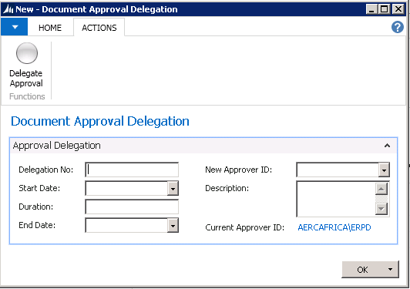

FIGURE 1.39 *Approval Delegations*

1. Click on **Delegate Approval**.

# Active Approval Delegations

This is used to view all the active approval delegations. Once a user comes back, they resume their approval duties.

1. Select **Departments**> **Self Service**> **Active Approval Delegations**.

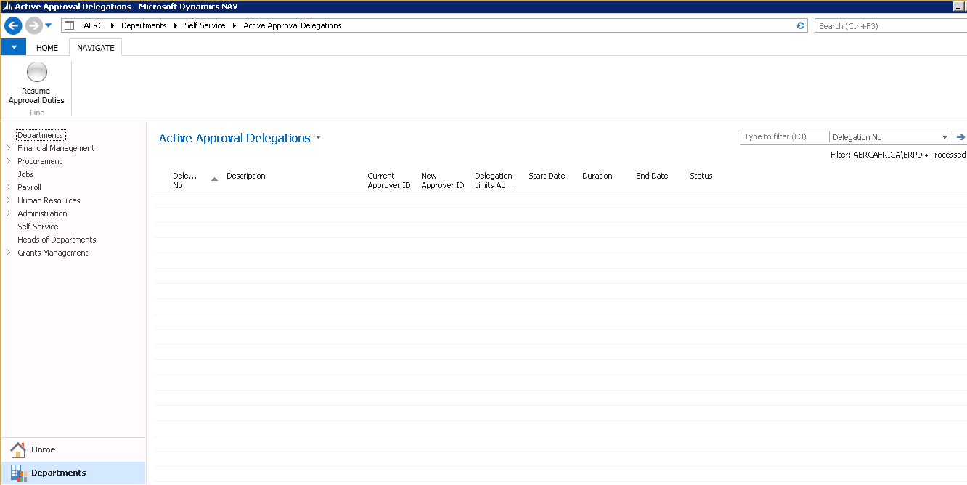

1. Select the approval delegation to revert.
2. Click on **Resume Approval duties**.

**End**

# Approval Request Entries

This contains all the requests that have been sent for approval and their status.

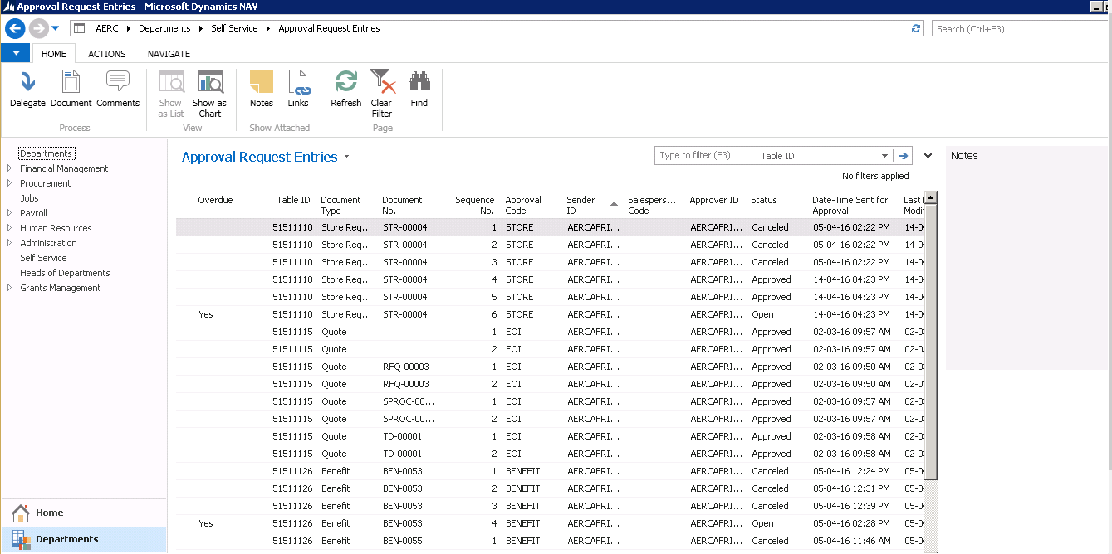

FIGURE 1.30 *Approval Request Entries.*

# Approval Entries

This contains a list of all items that need approval from the user that is logged into the system. The user can click on Document to view the details of the request. Then based on what they see, they may:

**Approve**: this gives a go ahead to the applicant

**Reject**: this means that the applicant’s application is unsuccessful

**Delegate**: this is if the approver is unable to respond to the request at that moment and it is urgent.

**Escalate**: this is if the approval requires attention from someone else with more authority.

**Comments**: these are added for whatever approval option is taken.

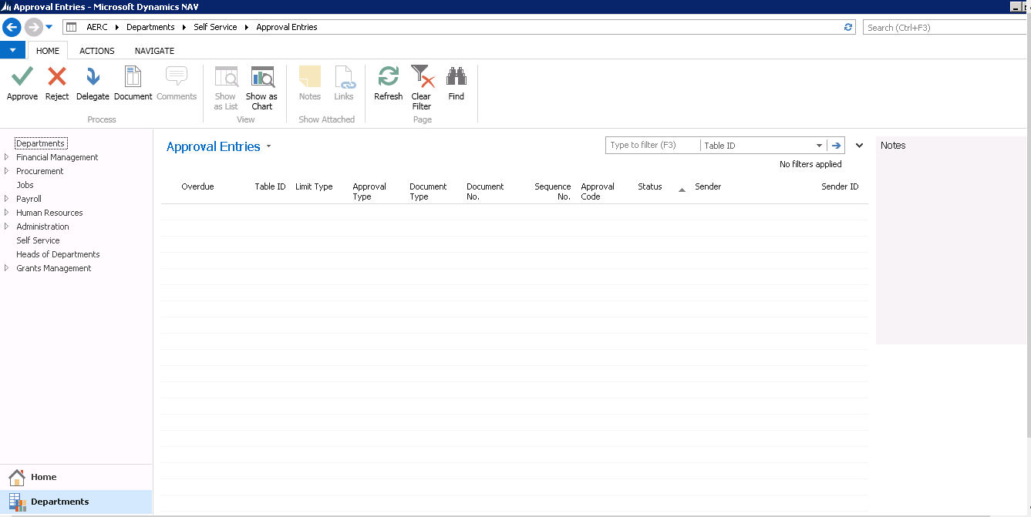

FIGURE 1.31 *Approval Entries*

# 20. Imprest/Advance Request

To request for imprest follow these steps:

1. Click **Departments>Self-service**

2. Select **Imprest Listing**

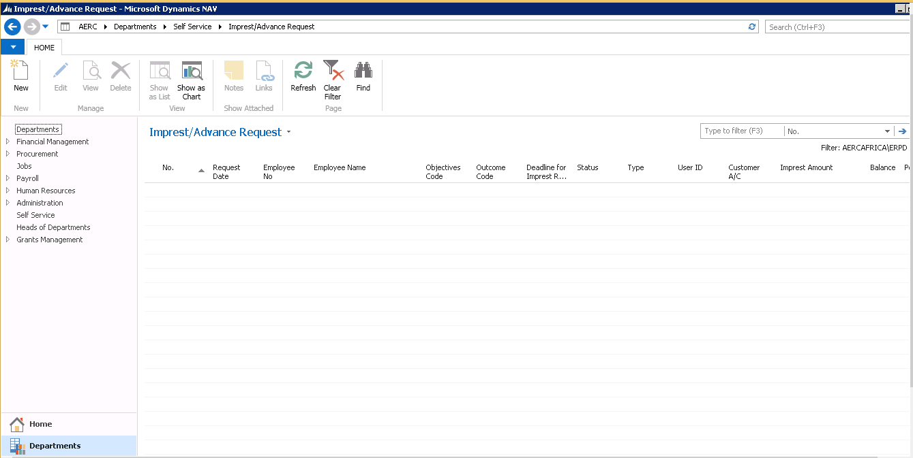

FIGURE 1.23 *Imprest Listing*

3. Click **New** and populate the resulting form.

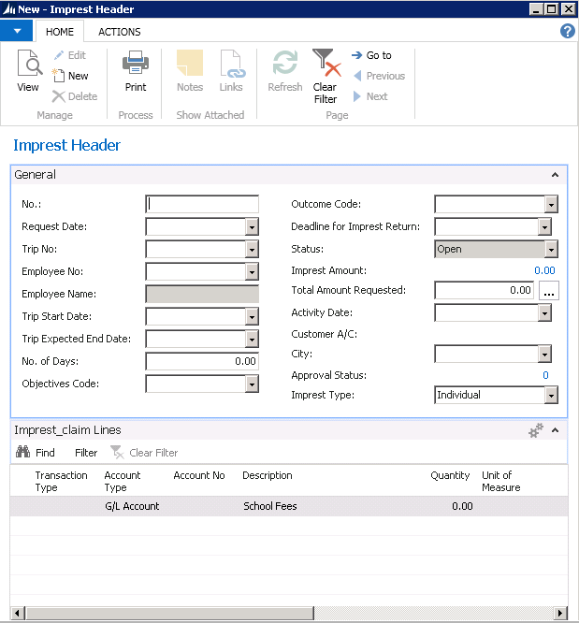

FIGURE 1.24 *Imprest form*

4. The field No. is auto populated.

5. On the Request Date field select the date.

6. If the imprest is related to a trip select the Trip No., and the Trip Start date and Strip end date are auto filled. The number of days are also filled out.

7. In the Transaction type field, select the appropriate transaction.

8. On the imprest lines enter the description, quantity, and unit price.

9. To send for approval request go to Actions, and select functions and then send approval request.

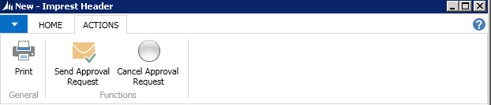

# Imprest/Advance Surrender

This is used to surrender or account for the imprest that was applied for successfully.

1. Click **Departments**> **Self Service**.

2. Select **Imprest/Advance Surrender**

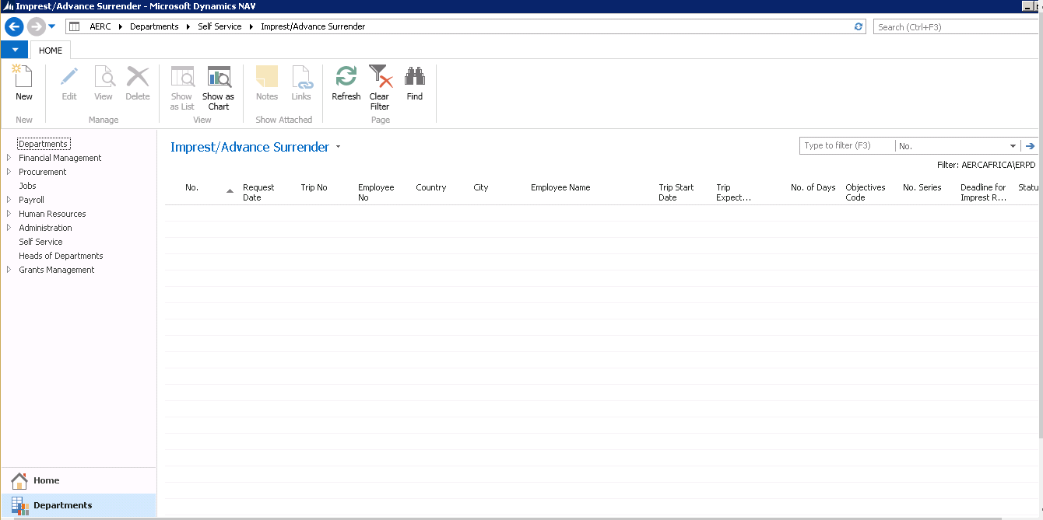

3. Click **New** and fill out the resulting form.

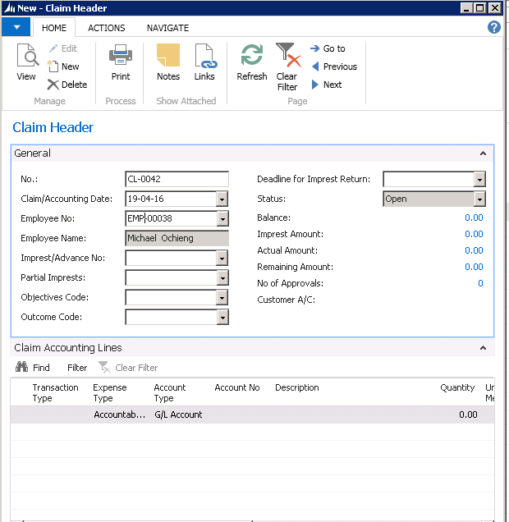

FIGURE 1.25 *Imprest Surrender/Accounting*

4. The field No. is auto populated

5. In the Claim/Accounting date enter the date of claiming or accounting. The Imprest/Advance No. are also selected if they are there.

6. If the imprest is related to a trip select the Trip request No., and enter Trip Start date and Strip end date

7. In the Transaction type field, select the appropriate transaction

8. In the applies to Doc. No. select the document to which the imprest surrender relates to

8. On the imprest lines enter the description, quantity, and unit price

9. To send for approval request go to Actions, and select functions and then send approval request 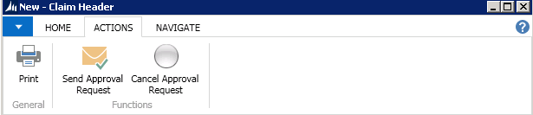

# Claims Refund Listing

This is to make claims on individual money spent in the course of company duty.

1. Click on **Departments**>**Self Service**> **Claims Refund Listing**

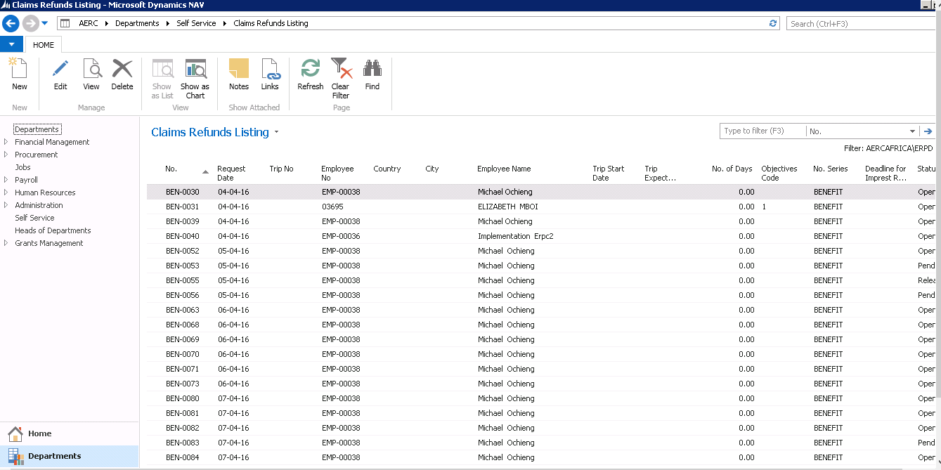

FIGURE 1.32 *Claims Refund Listing*

1. Click New and proceed to enter the relevant details relating to the claim.

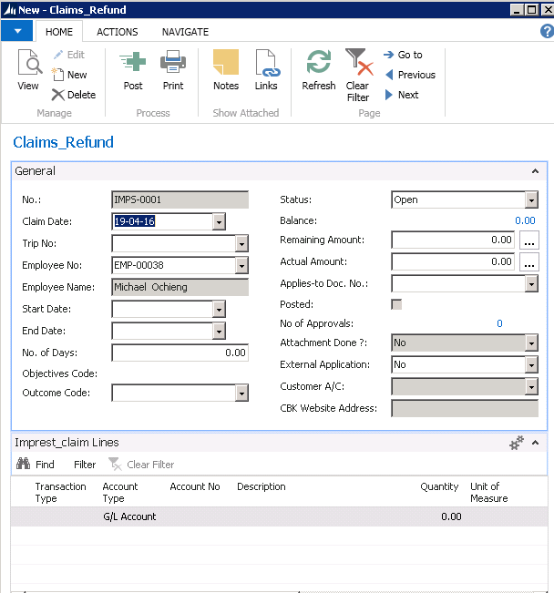

FIGURE 1.33 *Claims Refund form*

1. If the claim relates to a trip, select the trip No. and on the Imprest Claim Lines fill in the description, quantity, unit of measure, unit price and the total amount is computed.
2. Once all the fields are populated, click on Actions and click **Send Approval Request**.



# Education Benefits

This contains a list of the education benefits of the user 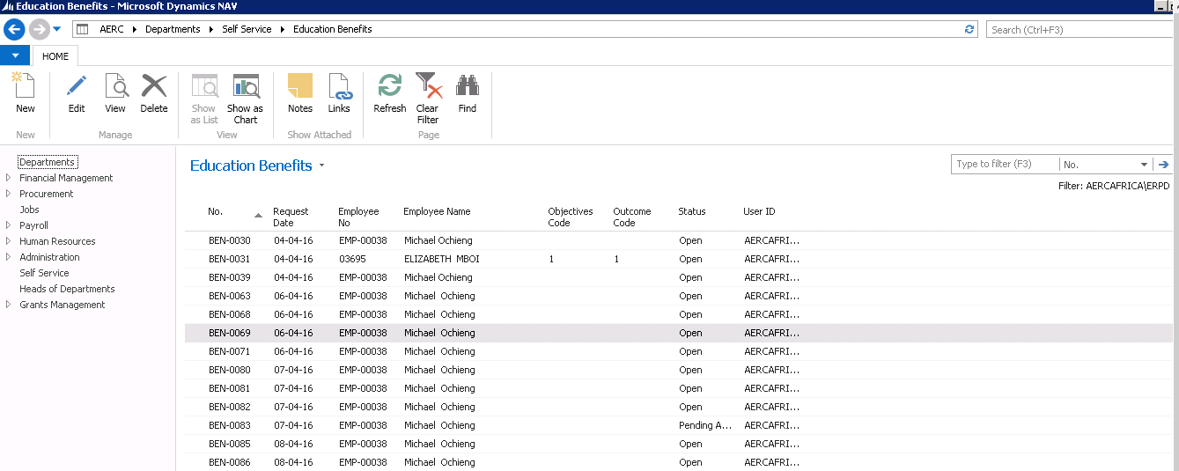

. Click **New** and populate the resulting form. 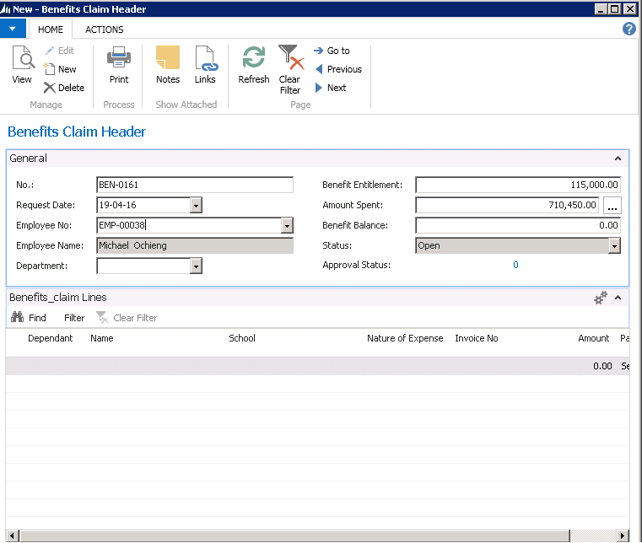

To send for approval request go to actions and chose the send approval request to the relevant approver 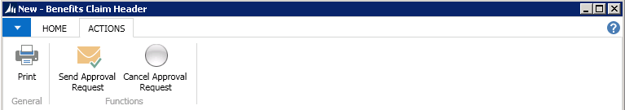

# Health Club Claims

This contains a list of the health club claims of the user 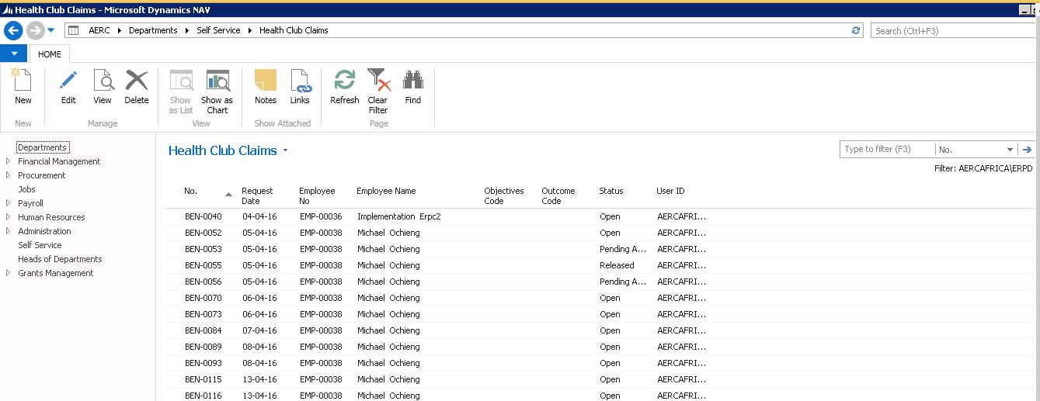

Click **New** and populate the resulting form. 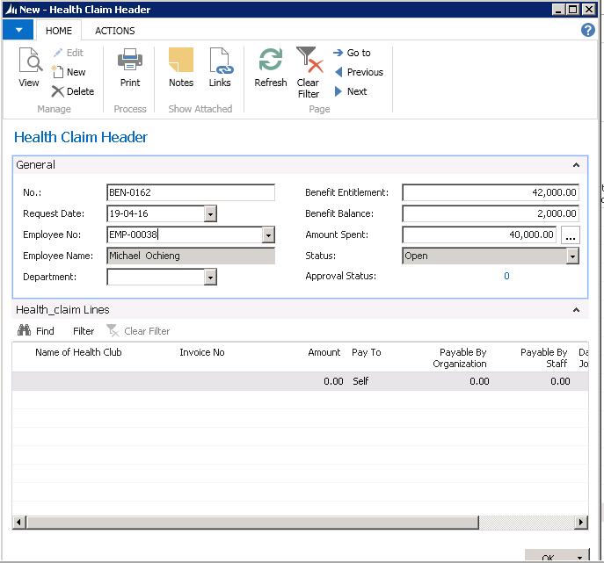

To send for approval request go to actions and chose the send approval request to the relevant approver 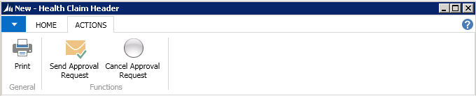

# Employee Medical Claims

This contains a list of the employee medical claims of the user 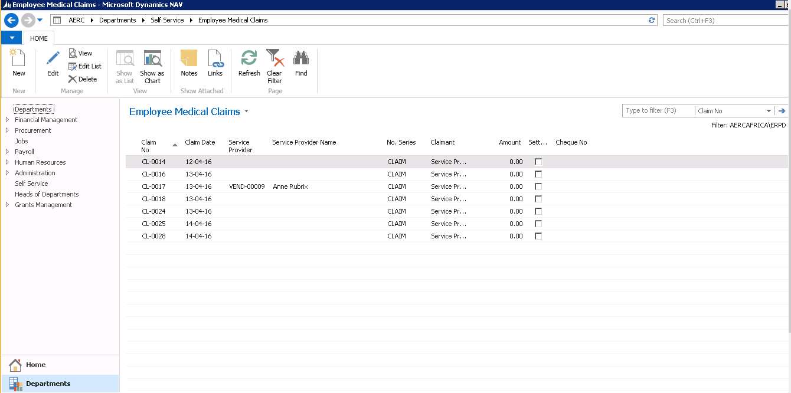

Click **New** and populate the resulting form. 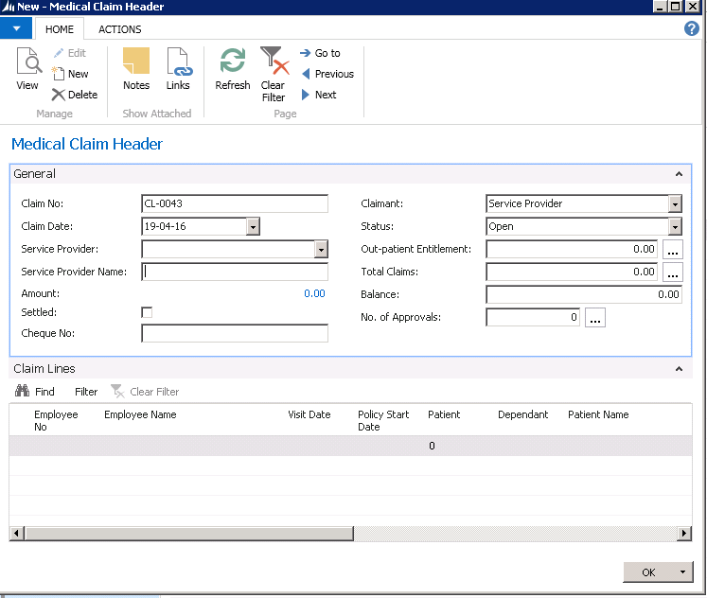

To send for approval request go to actions and chose the send approval request to the relevant approver 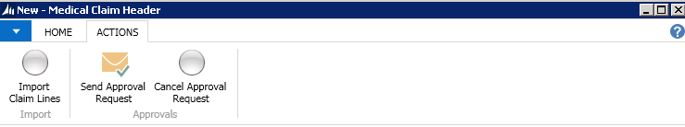

# Sick Offs List

This contains a list of Sick Offs of the user 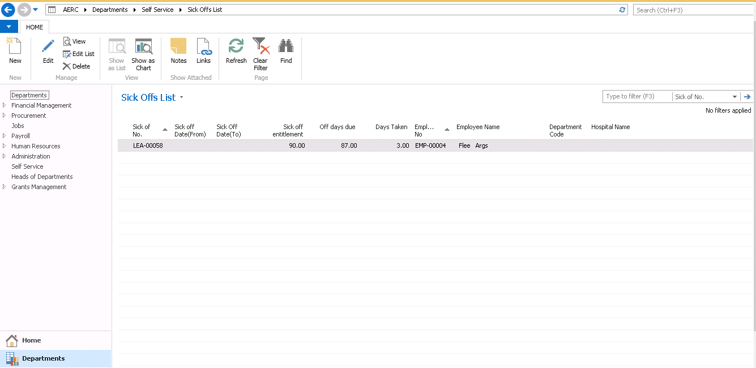

# 

Click **New** and populate the resulting form. 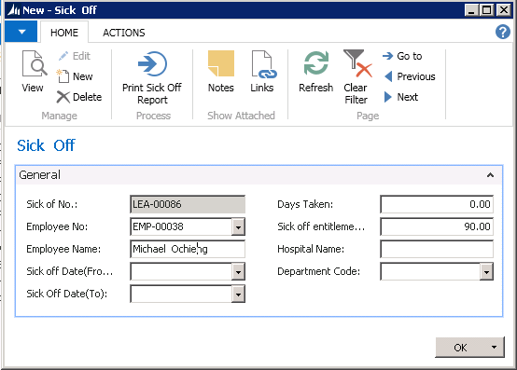

To print the Sick Off report go to actions and select print sick off report 